**Matlab 1.3.13**

a) Convolution smoothens the signal removing high frequency components from the input signal.

b) Length of input x =600

Length of output y =610

Length of impulse response h =11

Length of output y = Length of input x + Length of impulse response h -1

c)

Input and output signals do not line up.

d) Length of y2 = 600

First 5 and last 5 samples of signal from output removed by using commands and lengths of input and out matches.

e) h = ones(1,31)/31;

y3 = conv(x, h);

y3(1:15) = [];

y3(end-14:end) = [];

f) h = ones(1,67)/67;

y4 = conv(x, h);

y4(1:33) = [];

y4(end-32:end) = [];

**1.3.7**

f(n) = a^(n)* u(n)

g(n) = f(−n) = a^( −n)* u(−n)

a =0.9

1.3.8

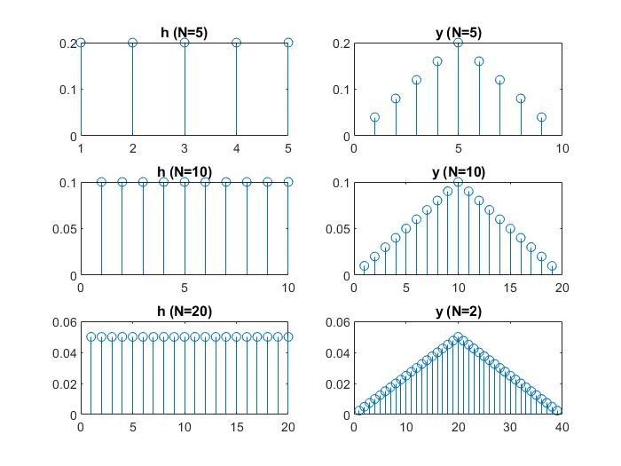

General Expression= (u[n]-u[n-N-1]).(1/N) * (u[n]-u[n-N-1]).(1/N)

**1.3.10**

